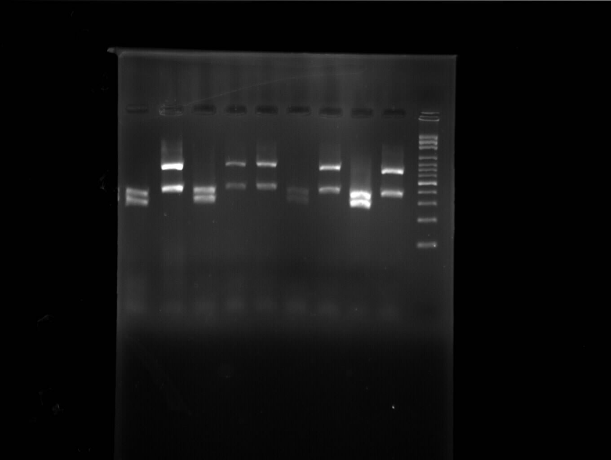
Fig S1. Agarose gel electrophoresis for PCR-RFLP; from left to right: C. albicans, C. glabrata, C. albicans, C. glabrata, C. glabrata, C. albicans, C. glabrata, C. albicans, C. glabrata, and 100 bp DNA size Marker

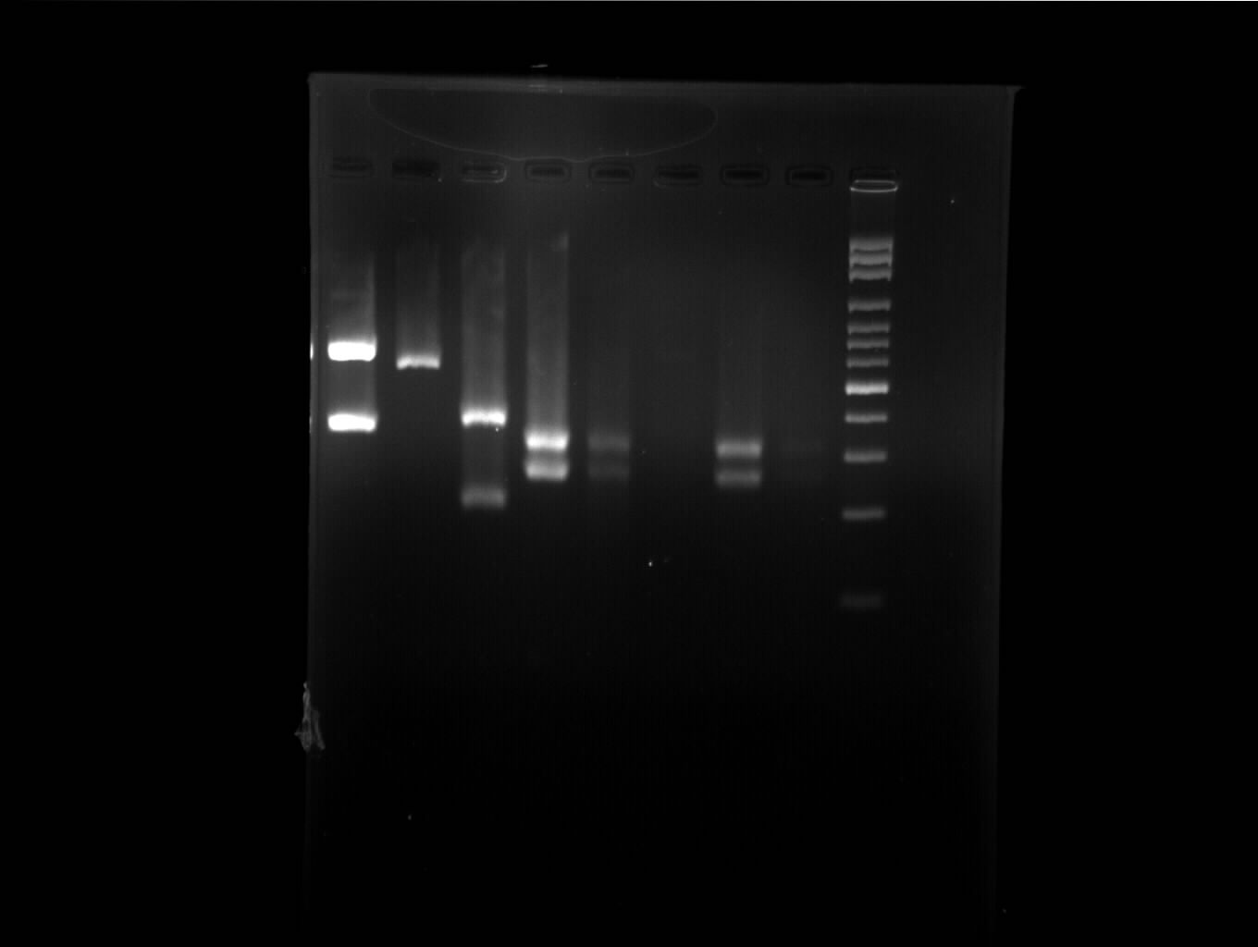
Fig S2. Agarose gel electrophoresis for PCR-RFLP; from left to right: C. glabrata, C. parapsilosis, C. tropicalis, C. albicans, C. albicans, No band, C. albicans, C. albicans (dim band), and 100 bp DNA size Marker

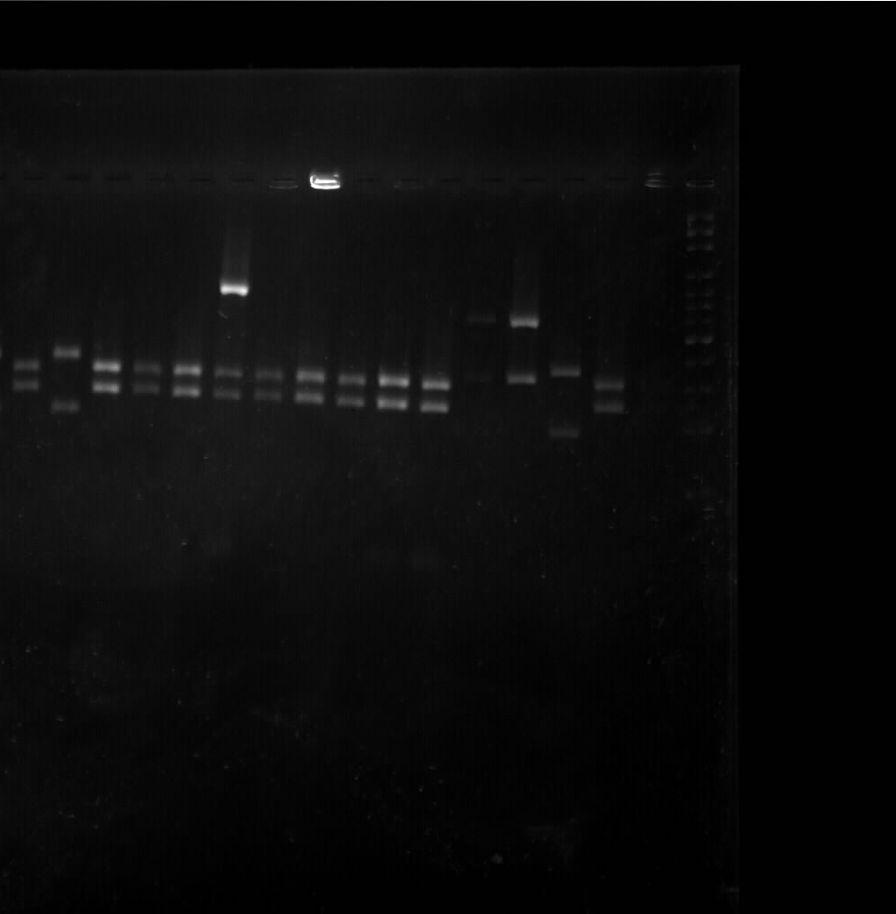
Fig S3. Agarose gel electrophoresis for PCR-RFLP; from left to right: C. albicans, C. tropicalis, C. albicans, C. albicans, C. albicans, Mixed bands (C. albicans, and C. kefyr), C. albicans, C. albicans, C. albicans, C. albicans, C. albicans, C. glabrata, C. glabrata, C. tropicalis, C. albicans, and 100 bp DNA size Marker

Repeat experiments
In this step, we selected 40 strains including Candida albicans, C. tropicalis, C. kefyr, C. parapsilosis complex, and C. glabrata complex randomly, and repeated PCR-RFLP test to confirm our primary findings. All results in this stage were consistent with the findings in the first stage.

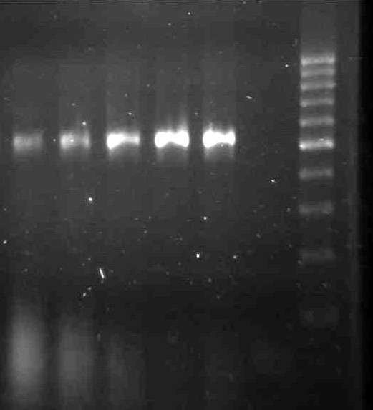
Fig S4. Agarose gel electrophoresis for PCR-RFLP; from left to right: C. parapsilosis, C. parapsilosis, C. parapsilosis, C. parapsilosis, C. parapsilosis, No band, and 100 bp DNA size Marker

Repeat experiments

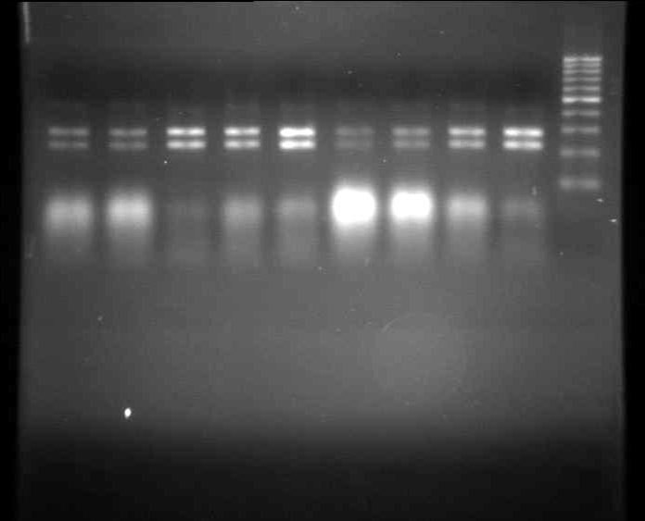
Fig S5. Agarose gel electrophoresis for PCR-RFLP; from left to right: C. albicans, C. albicans, C. albicans, C. albicans, C. albicans, C. albicans, C. albicans, C. albicans, C. albicans, and 100 bp DNA size Marker

Repeat experiments

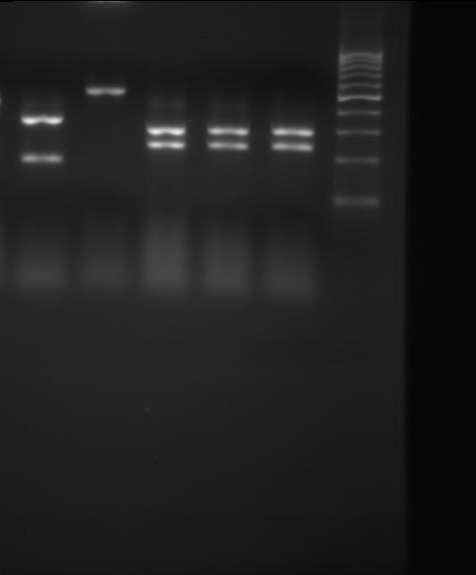
Fig S6. Agarose gel electrophoresis for PCR-RFLP; from left to right: C. tropicalis, C. parapsilosis, C. albicans, albicans, albicans,, and 100 bp DNA size Marker

